Waverley Memorial Elementary School
Wall of Honour

A WALL OF HONOUR will be displayed in the main foyer in November to honour family members of our WMES community. This will provide opportunities for our students and staff to display pictures and write-ups of family who have served in the military. These photos give us a glimpse of the faces of men and women who went off to war many years ago, and even more recently. We will also be creating a digital Wall of Remembrance to share in our Virtual Remembrance Day Assembly on November 10th.

It is our hope, that by seeing these faces, it will help us realize and understand (even in a small way) the courage and bravery of our veterans.

If you are interested in participating in this project please use the template provided and send your photos in digitally to the school by November 6th. (Hard copies are also accepted). We would also encourage students to include a photo of themselves so that we can make a connection to the family member.
We will return all hard copies of photos at the end of the month - but we do encourage you to send in copies (or photocopies) of original photos.

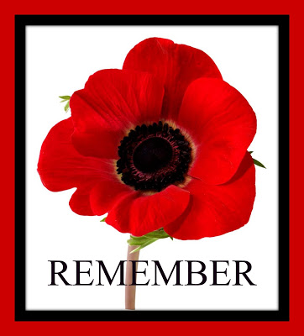
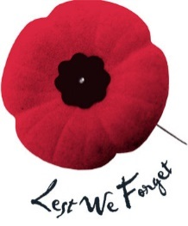
Attach photo of yourself
Attach photo of your family member who has served / or is currently serving.
Name of Veteran:

Service and When Served:

Relationship:

Student and Class:

