Waverley Memorial Elementary School
Wall of Honour

Each year at WMES we display A WALL OF HONOUR in the main foyer in November to honour family members of our WMES community who have served, and/or who are still serving our country.
We would like to give all staff and students an opportunity to be a part of this tribute by sending in some photos / memories to share.
These photos give us a glimpse of the faces of men and women who went off to war many years ago, and even more recently. We will also be creating a digital Wall of Remembrance to share in our Virtual Remembrance Day Assembly on November 10th.

It is our hope, that by seeing these faces, it will help us realize and understand (even in a small way) the courage and bravery of our veterans.

If you are interested in participating in this project please send us in a small poster to display in our foyer. We have included a template you may print and use, but please feel free to create your own if you prefer. You can create and send your posters in digitally and we will print to display, or you can send in the actual poster.
Please send in by November 9th. We would also encourage students to include a photo of themselves so that we can make a connection to the family member.
We will return all hard copies of photos at the end of the month - but we do encourage you to send in copies (or photocopies) of original photos.

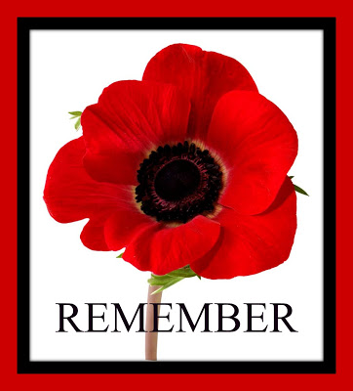
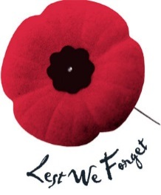
Attach photo of yourself
Attach photo of your family member who has served / or is currently serving.
Name of Veteran:

Service and When Served:

Relationship:

Student and Class:

